Beeston Methodist Church
Guidelines for dealing with visitors outside our premises.
As the people of the Methodist Church we are concerned with the wholeness of each individual within God’s purpose for everyone. We seek to safeguard all members of the church community of all ages. It is the responsibility of each one of us to prevent the physical, sexual or emotional abuse of children, young people and vulnerable adults.
When dealing with visitors outside our church premises remember to treat everyone with respect.
- Some visitors may request hot drinks. It is permissible to give drinks provided you feel comfortable and there are at least two people present.
- The person who gives the drink is responsible for collecting the cups and washing up (tea bags should not be left in cups as they can end up blocking the drain).
- Always say no to requests for money or food (refer people to the support of the Hope café who do serve food and have a food bank).
- As with all visitors contributions for drinks can be made to the church charity.
- If someone is drunk or abusive or behaves in a threatening manner they are to be politely asked to leave and told that they are not welcome back at the church for the next week.
- Any aggression should be dealt with by immediately phoning the Police Community Support Officers (PCSOs): Paula Hipkis 07702 141791 or Craig Gealy 07545 701 863, if unavailable dial 999 (church postcode NG9 1EH). Remain inside, out of sight and await their arrival. If you are just arriving, leave immediately.
- When working on your own on church premises and there is no-one else in the building, keep all external doors locked. When there are other users in the building make them aware of where you are working. Take sensible precautions to avoid carrying out task with a high degree of risk and know what to do in the case of an emergency.
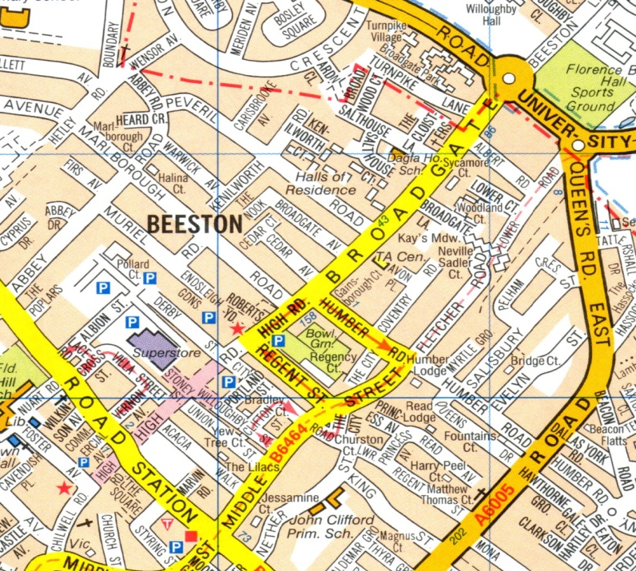

The Hope Café is on Boundary Rd, Beeston
They will fill flasks with hot drinks. There is a food bank available there.

Opening Times:
Monday & Wednesday 9.30am to 12pm
Thursday & Saturday 9.30am to 10.30am

